**Virologica Sinica**

**Supplementary materials**

**NSUN2 mediates distinct pathways to regulate** **enterovirus 71 replication**

Lishi Liu a, b, 1, Zhen Chen a, 1, Kui Zhang a, b, Haojie Hao a, Li Ma a, b, Haizhou Liu a, Xiang Guo a, b,Shuang Ding a,

Xueyan Zhang a, Miao Zhu a, b,Baocheng Yu a, b, Yi Liu c, Haibin Liu a, Fang Huang c, *, Ke Peng a, c, *, Wuxiang Guan a, c, *

a Center for Emerging Infectious Diseases, Wuhan Institute of Virology, Center for Biosafety Mega-Science, Chinese Academy of Sciences, Wuhan, Hubei, 430071, China

b University of Chinese Academy of Sciences, Beijing, 100049, China

c Hubei Jiangxia Laboratory, Wuhan, Hubei, 430200, China

* Corresponding authors:

Email addresses: guanwx@wh.iov.cn (W. Guan); pengke@wh.iov.cn (K. Peng); huangf@wh.iov.cn (F. Huang).

ORCID: 0000-0002-2415-4659 (W. Guan); 0000-0003-0172-8725 (K. Peng); 0000-0002-0511-2568 (F. Huang).

1 Lishi Liu and Zhen Chen contributed equally to this work.

Table S1. qPCR primer and sequence

|  |  |
| --- | --- |
| qPCR primer | Sequence |
| GAPDH-F | 5′-GAAGGTGAAGGTCGGAGTC-3′ |
| GAPDH-R | 5′-GAAGATGGTGATGGGATTTC-3′ |
| GAPDH (mice)-F | 5′-CATCACTGCCACCCAGAAGACTG-3′ |
| GAPDH (mice)-R | 5′-ATGCCAGTGAGCTTCCCGTTCAG-3′ |
| EV71-F | 5′-CGAATGCTAGTGATGAGAGTAT-3′ |
| EV71-R | 5′-GAGGAAGATCTATCTCCCCAACT-3′ |
| eGFP-F | 5′-TGAGCAAAGACCCCAACGAG-3′ |
| eGFP-R | 5′-CTTGTACAGCTCGTCCATGC-3′ |
| Luciferase-F | 5′-TCGAAAGAAGTCGGGGAAGC-3′ |
| Luciferase-R | 5′-ATCCCCCTCGGGTGTAATCA-3′ |

Notes: The table shows the sequences of the qPCR primers used in this study.

Table S2. The m5C sites of EV71 RNA detected by Direct RNA sequencing

|  |  |  |  |
| --- | --- | --- | --- |
| Vero | | RD | |
| location | score | location | score |
| 584 | 0.9929 | 584 | 0.9934 |
| 1460 | 0.9736 | 1460 | 0.9605 |
| 2637 | 0.9468 | 2637 | 0.9492 |
| 7009 | 0.9546 | 7009 | 0.9293 |
| 108 | 0.9265 | 108 | 0.9669 |
| 207 | 0.9535 | 207 | 0.94 |
| 231 | 0.9243 | 287 | 0.9237 |
| 287 | 0.9106 | 364 | 0.9636 |
| 364 | 0.913 | 473 | 0.9585 |
| 473 | 0.9486 | 495 | 0.9371 |
| 480 | 0.9375 | 587 | 0.996 |
| 495 | 0.9429 | 753 | 0.9156 |
| 587 | 0.9881 | 772 | 0.9589 |
| 735 | 0.9101 | 961 | 0.9935 |
| 772 | 0.963 | 984 | 0.9421 |
| 811 | 0.9515 | 1000 | 0.9074 |
| 961 | 0.9735 | 1024 | 0.9244 |
| 984 | 0.9306 | 1108 | 0.9131 |
| 1024 | 0.9402 | 1133 | 0.9182 |
| 1108 | 0.9111 | 1271 | 0.9354 |
| 1133 | 0.9225 | 1277 | 0.9163 |
| 1271 | 0.9522 | 1394 | 0.9445 |
| 1277 | 0.9324 | 1434 | 0.917 |
| 1286 | 0.9315 | 1568 | 0.904 |
| 1301 | 0.9078 | 1639 | 0.9048 |
| 1394 | 0.9554 | 1685 | 0.9207 |
| 1568 | 0.9121 | 1708 | 0.9138 |
| 1639 | 0.914 | 1741 | 0.9413 |
| 1708 | 0.9176 | 1853 | 0.9192 |
| 1741 | 0.954 | 1854 | 0.9134 |
| 1853 | 0.9314 | 1904 | 0.9043 |
| 1854 | 0.9486 | 1926 | 0.9918 |
| 1904 | 0.9277 | 1938 | 0.9156 |
| 1926 | 0.9887 | 2119 | 0.922 |
| 1938 | 0.9169 | 2121 | 0.9574 |
| 2119 | 0.9427 | 2639 | 0.9142 |
| 2121 | 0.9441 | 2665 | 0.9568 |
| 2531 | 0.9189 | 2811 | 0.9509 |
| 2639 | 0.9198 | 2941 | 0.9086 |
| 2665 | 0.97 | 2942 | 0.9859 |
| 2811 | 0.9303 | 3078 | 0.9508 |
| 2917 | 0.9053 | 3096 | 0.9387 |
| 2941 | 0.9017 | 3114 | 0.929 |
| 2942 | 0.9899 | 3115 | 0.9346 |
| 3078 | 0.959 | 5677 | 0.9148 |
| 3096 | 0.9339 | 5704 | 0.9003 |
| 3114 | 0.9431 | 7187 | 0.9107 |
| 3115 | 0.9535 |  |  |
| 4242 | 0.9135 |  |  |
| 5704 | 0.9109 |  |  |

Notes: Direct RNA sequencing was conducted using the poly A-purified RNAs from EV71-infected Vero cells and RD cells. The m5C sites shown in Figure 1D were clearly presented as data in the supplemental table 2.

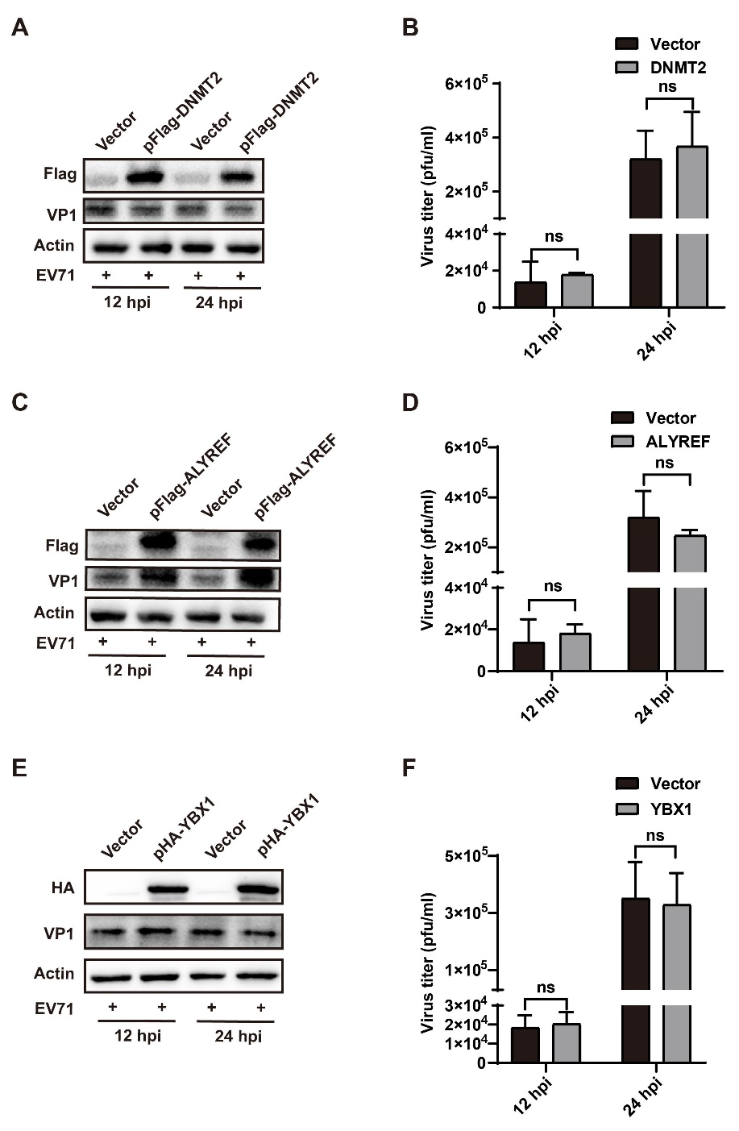

**Figure S1.** DNMT2, ALYREF and YBX1 do not affect enterovirus 71 (EV71) replication. **A, C, E** EV71-infected RD cells were transfected with an empty vector or indicated plasmids. At 12 h (left two lanes) and 24 h (right two lanes) post-transfection, the expression levels of DNMT2, ALYREF, YBX1, VP1 and Actin proteins were detected using the indicated Abs. **B, D, F** Numbers of progeny EV71 viruses in RD cells were measured at 12 h (left two bars) and 24 h (right two bars) and presented as a bar graph.Unpaired Student’s *t*-tests were performed for all bar graphs, and data are presented as the means ± SEMs (n = 3). \**P* ≤ 0.05, \*\**P* ≤ 0.01. ns: not significant, two-way ANOVA.

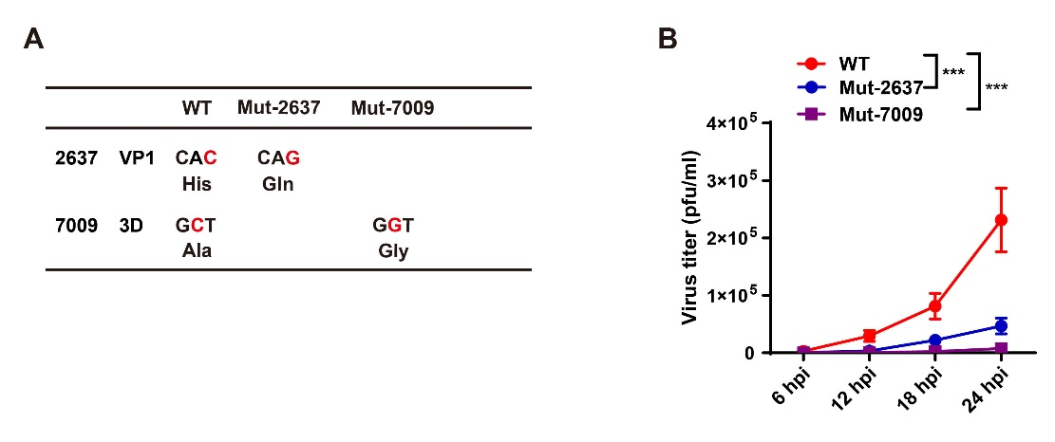

**Figure S2.** 5-Methylcytosine (m5C) modifications promote enterovirus 71 (EV71) replication. **A** The diagram of Mut-2637 and Mut-7009 EV71 strains relative with WT EV71. **B** The TCID50 virus titers of progeny EV71 viruses in Vero cells infected with WT or the other three mutant EV71 strains from (**A**) were measured at multiple time points (0, 6, 12, 18, and 24 h) and presented as a line chart. Unpaired Student’s *t*-tests were performed for the line chart, and data are presented as the means ± SEMs (n = 3). \*\*\**P* ≤ 0.001.

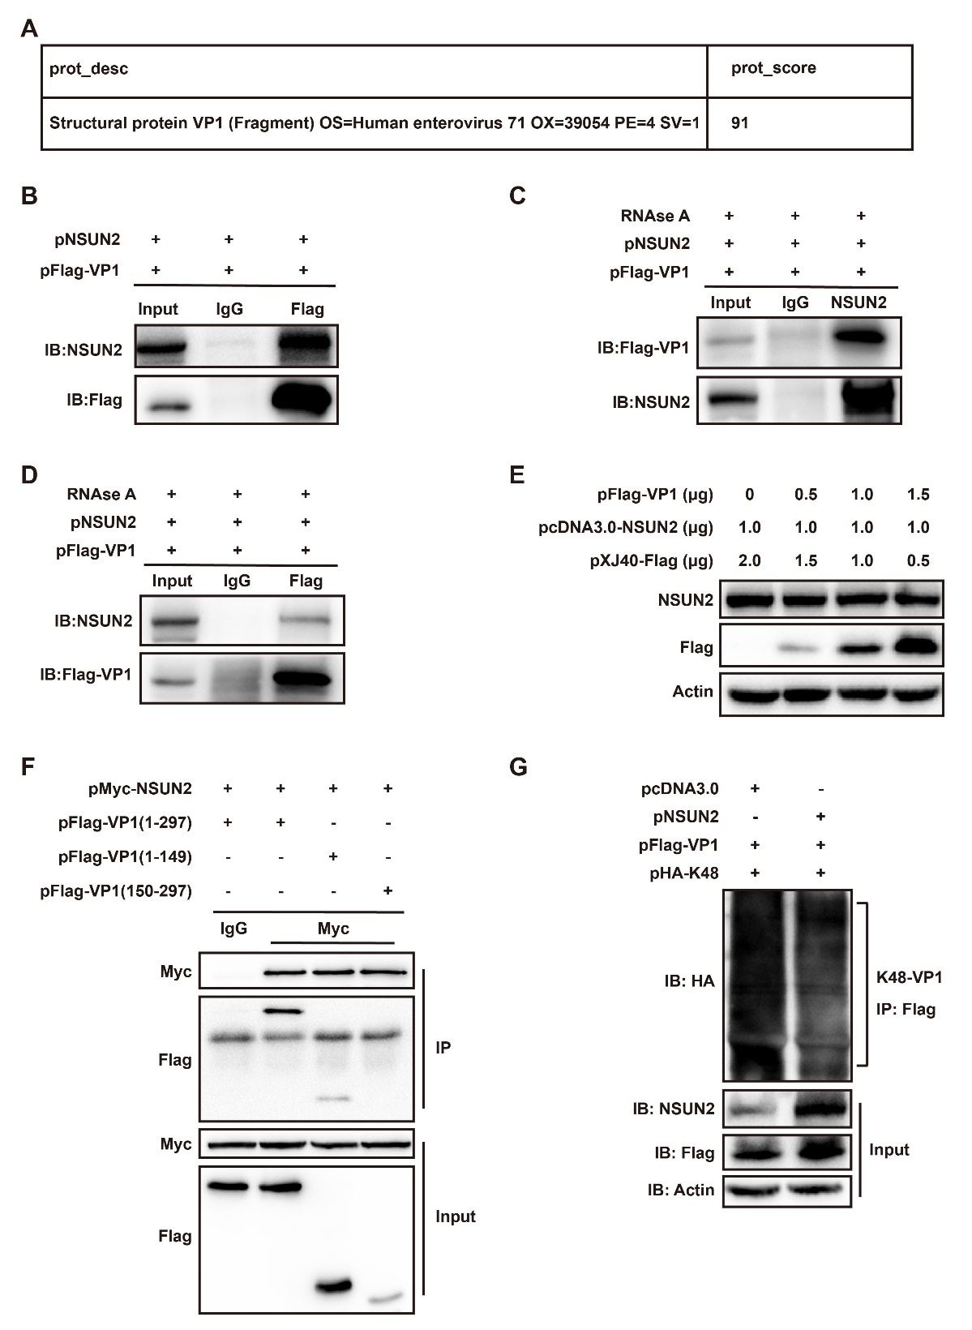

**Figure S3.** NSUN2 targets VP1 for binding in an RNA-independent manner and inhibits its K48 ubiquitination. **A** The table presents one of the proteins pulled down with NSUN2, specifically VP1, and the indicated scores according to the mass spectrum (MS) analysis. **B** VP1 targets NSUN2 for binding. Co-IP samples using anti-Flag Abs (right 2 lanes) and input samples (left lane) obtained from RD cells expressing exogenous NSUN2 and VP1 were examined using the indicated Abs. **C, D** NSUN2 targets VP1 for binding in an RNA-independent manner. Co-IP samples obtained from the RNase A-treated RD cells expressing NSUN2 and VP1 using anti-NSUN2 (**C**) or anti-Flag (**D**) and input samples were separately examined using the indicated Abs. **E** Exogenous VP1 did not affect NSUN2 expression. Levels of NSUN2, VP1 and Actin were measured in RD cells co-transfected with a constant amount of NSUN2 plasmid and an increasing amount of VP1 plasmid using the indicated Abs. Empty vectors were supplemented for equal amounts of transfected plasmids. **F** VP1 interacts with NSUN2 via its N-terminus. Co-IP samples (top two panels) obtained from HEK293T cells expressing exogenous NSUN2 and VP1 (left two lanes) or two truncated mutants [VP1(1–149) and VP1(150–297)] using anti-Myc Abs and input samples (bottom 2 panels) were examined using the indicated Abs. **G** IP samples obtained from HEK293T cells expressing exogenous VP1 and mutant ubiquitin (only contain K48) with (left lane) or without (right lane) exogenous NSUN2 using anti-Flag Abs. Levels of VP1 ubiquitination were measured using anti-HA Abs (top panel), and input samples were measured using the indicated Abs (bottom three panels).

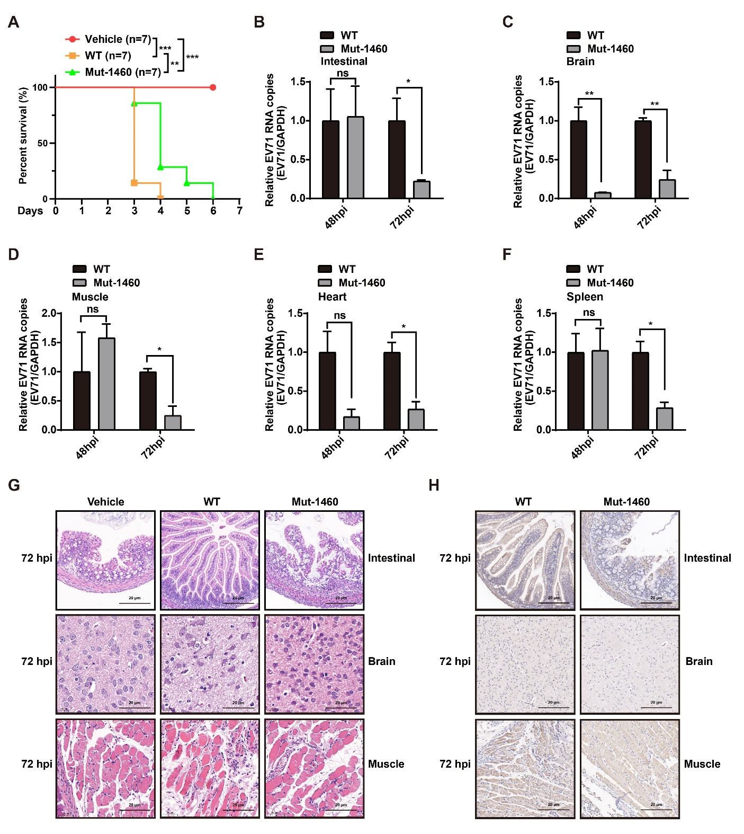

**Figure S4.** A mutant enterovirus 71 (EV71) strain (Mut-1460) lacking 5-methylcytosine (m5C)-modified residues exhibits significantly attenuated pathogenicity in mice. **A** Mice were separately challenged with the same numbers (105 pfu) of wild-type (WT, yellow) or m5C-mutant (Mut-1460) (green) EV71 strains, and DMEM was set as control (vehicle) (red). Each group consisted of seven mice, and the indicated survival time was measured and presented as a line chart. A log-rank (Mantel-Cox) test was performed (\**P* ≤ 0.05, \*\**P* ≤ 0.01). **B–F** After euthanizing AG6 mice challenged with WT or Mut-1460 EV71 strains for 48 h or 72 h, levels of viral RNAs in intestinal (**B**), brain (**C**), muscle (**D**), heart (**E**) and spleen (**F**), samples were quantified and presented as bar graphs. Unpaired Student’s *t*-tests were performed for the line chart and all bar graphs, and data are presented as the means ± SEMs (n = 3). \**P* ≤ 0.05, \*\**P* ≤ 0.01. ns: not significant. **G, H** After challenging mice with DMEM (vehicle) or WT or Mut-1460 EV71 viruses for 72 h, hematoxylin and eosin staining (**G**) or immunohistochemistry (**H**) to detect EV71 particles using anti-VP1 Abs was performed on the intestine (top panel), brain (middle panel), and limb muscle (bottom panel). The scale bar is 20 μm.